Simulation Worksheet: Kuiper Belt Interactions
Instructor Guidelines
The goal of this activity is for students to understand that there are possible orbits in the outer solar system where Kuiper Belt Objects (KBOs) are found and possible orbits where they are not found. Whether or not a KBO exists in a given orbit depends on its gravitational interaction with Neptune. This strongly parallels Jupiter 's interaction with the asteroid belt and the Kirkwood Gaps.
This worksheet makes use of simulations contained in the Virtual Laboratories, a commercial product published by Brooks/Cole. These particular simulations have been made publicly available for promotional purposes and will remain available. It is assumed that each student in the class will have their own photocopy of the worksheet that they will annotate and the instructor will project the two simulations and use them to guide students through the activity.
- Simulation 1: KBO Orbital Parameters (available at http://astro.unl.edu/vlabs/outer_dist.html)
This interactive graph plots the eccentricities versus the semimajor axes of several hundred KBOs.
- Simulation 2: KBO-Neptune Simulator (available at http://astro.unl.edu/vlabs/kbo_sim.html )
This simulation illustrates the orbit of Neptune looking down onto the plane of our solar system. It allows one to specify a KBO orbit's eccentricity and semimajor axis. One can animate the orbital motion and it graphically shows the distance between Neptune and the KBO over time.
Simulation Subtleties
- #2-Dragging the speed slider to zero stops the simulation.
- #2-All KBO's are created on the other side of the sun from Neptune.
- #1-The show perihelion distance lines option is very useful showing the effect of eccentricity on closest approach distance to Neptune. Any KBO on the upper left side of 30AU perihelion distance curve comes closer to the Sun than Neptune ever does at some point in its orbit.
Pedagogical Subtleties
- This activity suggests that the gravitational perturbation process was very sudden involving a close approach. Make clear to students that although that certainly occasionally happened, it is more likely that the scattering occurred slowly over a long period of time where Neptune made a long succession of small gravitational tugs. We can't show that very well in a simulator.
- Remind students that there is a third dimension -- orbits that appear to intersect in 2-D do not intersect in 3-D.
- This exercise can easily include student discussion with peers. This can occur for each KBO in part 2 under "describe the likely affect" and/or part 3.

Simulation Worksheet: Kuiper Belt Interactions
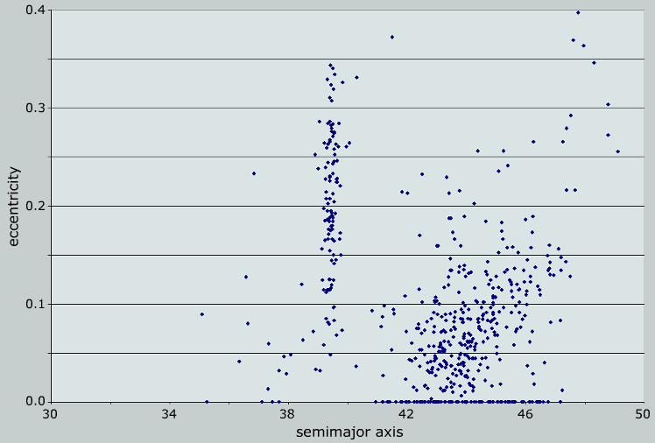
Use the diagram below showing the semimajor axis a and eccentricity e for ~500 KBO orbits in conjunction with the projected simulation to study the interaction between KBOs and Neptune.

1. The planet Neptune's orbit has a semimajor axis of 30 AU and is very close to circular (e =0). Add the planet Neptune (symbol N) to the diagram.
2. The Kuiper Belt is dominated by interactions with the planet Neptune (much like the asteroid belt is influenced by Jupiter). If a KBO passes within 3 AU of Neptune, it will be gravitationally perturbed and its orbit will be changed. For each of the following KBO's: i) add the KBO's symbol to your diagram, ii) note its interaction with Neptune in the simulator, and iii) describe the likely effect on the KBO.
A) a = 43 AU, e = 0.05 ______________________________________________________________
__________________________________________________________________________________
B) a = 32 AU, e = 0.15 ______________________________________________________________
__________________________________________________________________________________
C) a = 39.4 AU, e = 0.25 _____________________________________________________________
__________________________________________________________________________________
3) Astronomers often divide the Kuiper Belt into 3 subdivisions. A) Classical KBO's (far enough from Neptune to be uninfluenced), B) Scattered (KBOs that were thrown in to large elliptical orbits by Neptune), and C) Plutinos (objects that avoid Neptune by being in a 3:2 orbital resonance). Crudely sketch these regions on the diagram above.
Simulation Worksheet: Kuiper Belt Interactions Key
Use the diagram below showing the semimajor axis a and eccentricity e for ~500 KBO orbits in conjunction with the projected simulation to study the interaction between KBOs and Neptune.
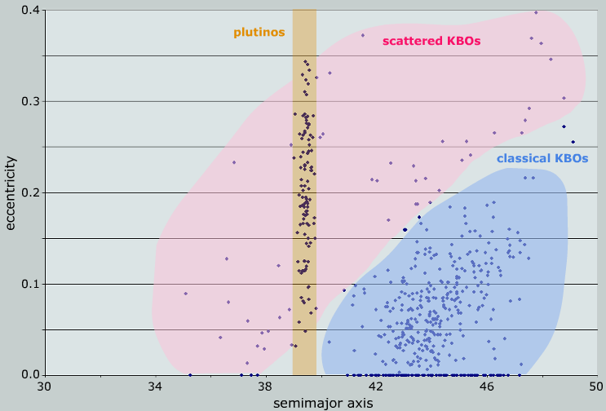

C

B
A

N

1. The planet Neptune's orbit has a semi-major axis of 30 AU and is very close to circular. Add the planet Neptune (symbol N) to the diagram.
2. The Kuiper Belt is dominated by interactions with the planet Neptune (much like the asteroid belt is influenced by Jupiter). If a KBO passes within 3 AU of Neptune, it will be gravitationally perturbed and its orbit will be changed. For each of the following KBO's: i) add the KBO's symbol to your diagram, ii) note their interaction with Neptune in the simulator, and iii) describe the likely effect on the KBO.
A) a = 43 AU, e = 0.05 _This KBO is far from the planet Neptune, it will likely by unaffected._____
__________________________________________________________________________________
B) a = 32 AU, e = 0.15 _this KBO comes very close to Neptune and over time will likely be scattered into a new orbit. Note that there are no KBOs with orbital parameters close to these values. ________
C) a = 39.4 AU, e = 0.25 __Although this KBO's orbit appears to cross Neptune's orbit (in 2D) it never gets very close. It orbits twice for every 3 Neptune orbits.______________________________
3) Astronomers often divide the Kuiper Belt into 3 subdivisions. A) Classical KBO's (far enough from Neptune to be uninfluenced), B) Scattered (KBOs that were thrown in to large elliptical orbits by Neptune), and C) Plutinos (objects that avoid Neptune by being in a 3:2 orbital resonance). Crudely sketch these regions on the diagram above. Shaded on diagram.

