Armillary Sphere 1: The Tropics Worksheet
to follow the video at
https://www.youtube.com/watch?v=JiWtt9WkVFc

Introduction
Declination is the angle of a point above or below the celestial equator, such that the CE has a declination of 0°, the NCP has a declination of 90° and the SCP has a declination of -90°. Declination is independent of the observer.
Identify the declination of the Sun on …
the summer solstice |  | °
the autumnal (or vernal) equinox |  | °
the winter solstice |  | °
Altitude is the angle of a point above or below the horizon, such that the horizon has an altitude of 0° and the zenith has an altitude of 90°. Every observer sees one celestial pole in the sky at an altitude equal to their latitude. If they are in the northern hemisphere, they see the NCP above their north point, while in the southern hemisphere, an observer sees the SCP above their south point. The CE is always 90° away from the celestial poles.
Meridional altitude is the altitude of an object as it crosses the meridian. The meridian divides the sky into an east half and a west half - picture an arc from the north point of the horizon, through the observer’s zenith point, to the south point of the horizon. Objects cross the meridian at their highest point in the sky (local noon for the sun).
Hint: The maximum altitude is 90°. So if you calculate that the Sun is 110° above the northern horizon by adding the declination of the sun and the meridional altitude of the CE. Then the sun is 70° above the southern horizon and has an altitude of 70°.
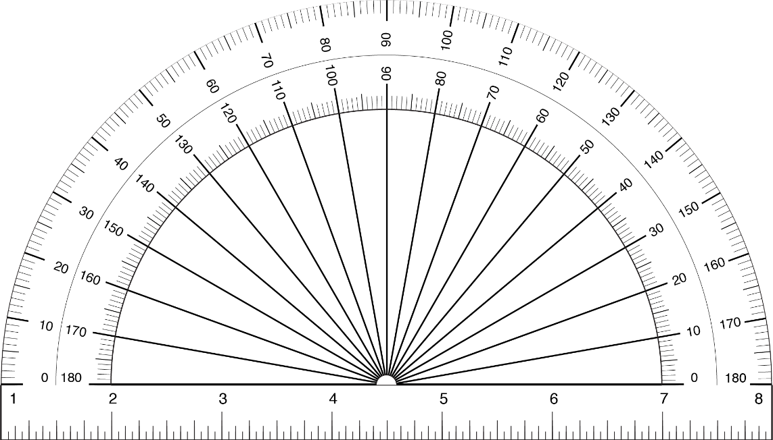
We can model meridional altitude using a protractor and specify reference points in the celestial equatorial system on the observer’s meridian. Note that meridional altitude is an altitude: it should always be less than 90°.
Z
N
S
Horizon Plane
Meridian
Meridian

Guided Example – Let’s consider an observer at a latitude of 15° N. Using the diagram answer the following questions:
SS
CE
Z
WS
Meridian

NCP

N
S
Horizon Plane

- the altitude of the NCP is |  | °
- the meridional altitude of the CE is |  | °
You should verify that the sum of these two numbers is 90°. Using the meridional altitude of the CE and the declination of the sun on each of these dates, calculate the meridional altitude of the sun for the observer at a latitude of 15° N on the following days.
- the summer solstice |  | °
- the autumnal equinox |  | °
- the winter solstice |  | °
We can estimate the number of days each year and the time of year when the Sun will be directly overhead (at the zenith) at local noon.
Note that your answer for question 3 was initially (before using the hint on page 1) greater than 90°. Thus, there is a day that precedes the summer solstice when the sun will pass through the zenith and a day after the SS (by a symmetrical number of days) when it will pass through the zenith. One can crudely estimate how much before and after by the spacing of the zenith between the CE and the SS.
- Estimate the time and the number of days each year when the Sun will be directly overhead at local noon for an observer at a latitude of 15° N?
______________________________________________________________________________

______________________________________________________________________________

Student Problem – Consider an observer at a latitude of 40° N. Annotate the diagram below and use it to answer the following questions:
Z
N
S
Horizon Plane
Meridian

Model the diagram above for an observer at latitude of 40° N and determine …
- the altitude of the NCP |  | °
- the meridional altitude of the CE |  | °
and the noon altitude on …
- the summer solstice |  | °
- the autumnal equinox |  | °
- the winter solstice |  | °
- Estimate the time of year and the number of days each year when the sun will be directly overhead at local noon for an observer at this latitude (40° N)?
______________________________________________________________________________
______________________________________________________________________________
Compare your answers to questions 6 and 12 and think about generally applying the concepts.

- How many days a year will the sun be directly overhead for an observer in the tropics? What is the range of latitudes defined as the tropics?
______________________________________________________________________________
______________________________________________________________________________
______________________________________________________________________________
______________________________________________________________________________

