**Sunspots Overhead** – Worksheet to follow the viewing of the demonstration movie at

<http://astro.unl.edu/video/demonstrationvideos>

**Background**

The continuous (blackbody) spectra produced by the photosphere of the sun are described by two laws:

Stefan-Boltzman Law:  where F is the flux, σ is a constant, and T is the temperature, which basically means that *each square meter of a hotter object’s surface emits more light at all wavelengths*.

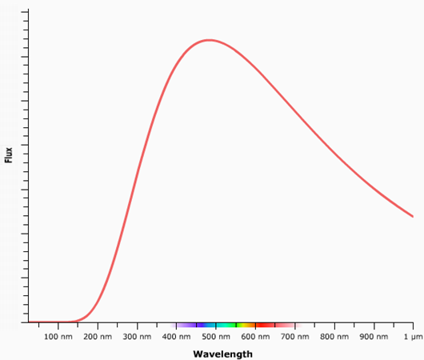*Wien’s Law*:  where λ is the peak wavelength in nanometers and c is a constant which basically means that *hotter objects emit photons with a higher peak (and average) energy*.

**Activity**

The blackbody spectrum above belongs to a typical area of the ***photosphere*** of the sun at a temperature of 6000 K. Label this curve photosphere. Its peak wavelength is approximately _____________nm and it is the color _________________.

A typical ***sunspot*** has a temperature of 4500 K. A sunspot will have a blackbody curve with {more/less} area underneath it meaning that {more/less} total light is produced and a peak wavelength that is at a {longer/shorter} wavelength value. Crudely draw the blackbody curve belonging to a sunspot and label it. A sunspot appears black but really has a color of ___________________.

Imagine that a very hot sunspot had a temperature of 5000 K – add its blackbody curve to the diagram.