Scattering Interactive Worksheet
to accompany the astronomy demonstration video at
https://www.youtube.com/watch?v=qh4CghdTPFs

Directions: This is an interactive worksheet to accompany the astronomy demonstration video on Scattering. You (or your instructor) should stop the video at the exact time index specified for each question and complete the associated question/task. The two peer instruction questions in the video are included, but other additional questions and tasks are included as well.

- (t = 0:57) The cylinder is filled with water, it is placed on the mask hole, and the projector is turned on.
  - Describe the appearance of the water in the cylinder.
__________________________________________________________________________________
__________________________________________________________________________________

  - Describe the appearance of the light that is projected on the screen.
__________________________________________________________________________________
_________________________________________________________________________________

- (t = 1:43) A small amount of pine sol (consisting of small scattering agents) is added to the water. Please circle your answer in the peer instruction question and then write out your reasoning.
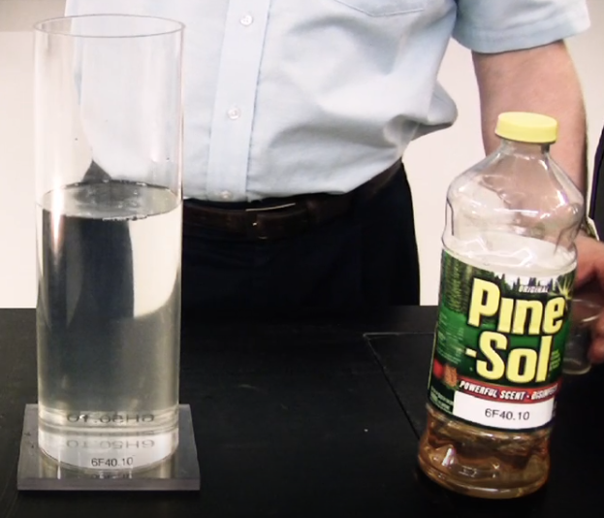
A cylinder filled with water and a little Pine Sol is placed upon the overhead mask and has white light shining through it. The water in the cylinder will appear slightly …

A) white
B) dark
C) red
D) blue
E) yellow

__________________________________________________________________________________
__________________________________________________________________________________
__________________________________________________________________________________
__________________________________________________________________________________

- (t = 2:11) The simplified diagram below depicts white light incident upon our cylinder of water with added pine sol (small scattering agents). Only a small number of blue and red photons are shown (blue photons are shown as dashed lines, red photons as solid lines).
Please sketch the ultimate paths of the photons after they interact with the water/pine sol mixture. Your sketch should loosely illustrate the principles of Rayleigh scattering and support what you have observed for the appearance of the cylinder and of the screen. Note that one blue photon has been scattered for you.
White Light
Screen
Blue Photons
Red Photons
water+pinesol

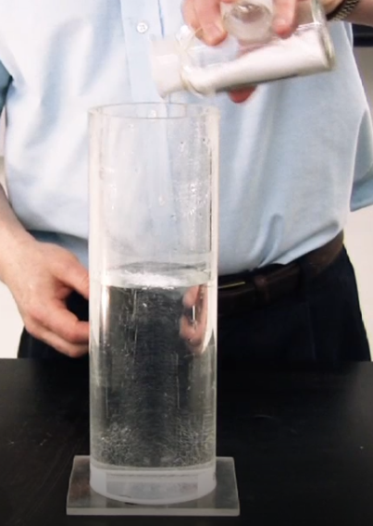
- (t = 3:20) A small amount of chalk dust (consisting of large scattering agents) is added to the water. Please circle your answer to the peer instruction question and then write out your reasoning.
A cylinder filled with water and a little chalk dust is placed upon the overhead mask and has white light shining through it. The water in the cylinder will appear slightly …

A) white
B) dark
C) red
D) blue
E) yellow

______________________________________________________________________________

______________________________________________________________________________

______________________________________________________________________________

- (t = 3:54) The simplified diagram below depicts white light incident upon our cylinder of water with a small amount of added chalk dust (large scattering agents). For simplicity only a small number of blue and red photons are shown (blue photons are shown as dashed lines, red photons as solid lines).
Please sketch the ultimate paths of the photons after they interact with the water/chalk dust mixture. Your sketches should loosely illustrate the principles of Mie scattering and support what you have observed for the appearance of the cylinder and of the screen. Note that one red photon has been scattered for you.
White Light
Screen
Blue Photons
Red Photons
water+chalk

