Charge Separation (Lightning) Worksheet
to follow the astronomy demonstration video at
https://www.youtube.com/watch?v=exuatm9I4Fk

Part 1: Complete the blanks in the narrative below describing the lightning creation process on Earth.

Lightning occurs due to the separation of charge on a grand scale. A large amount of charge builds up as materials are rubbing against each other due the ____________________________ in a storm cloud. The particular materials thought to be rubbing are water droplets and graupel (best described as ________________________). Updrafts carry the graupel upward and water droplets travel downward. _______________ are sheared off of the graupel leaving it ______________ charged and the downward traveling ___________________ negatively charged. The levels of charge build up at the tops and bottoms of storm clouds until some type of discharge is inevitable. The diagram below illustrates both a discharge between clouds and a ______________ to ____________ discharge. In addition to Earth, lightning has been observed on the planets _________________ and _______________ (and Venus too). Although the charge separation materials cannot be exactly the same as on Earth, the lightning is indicative of ____________________________ that cause materials to rub, shearing off charge.
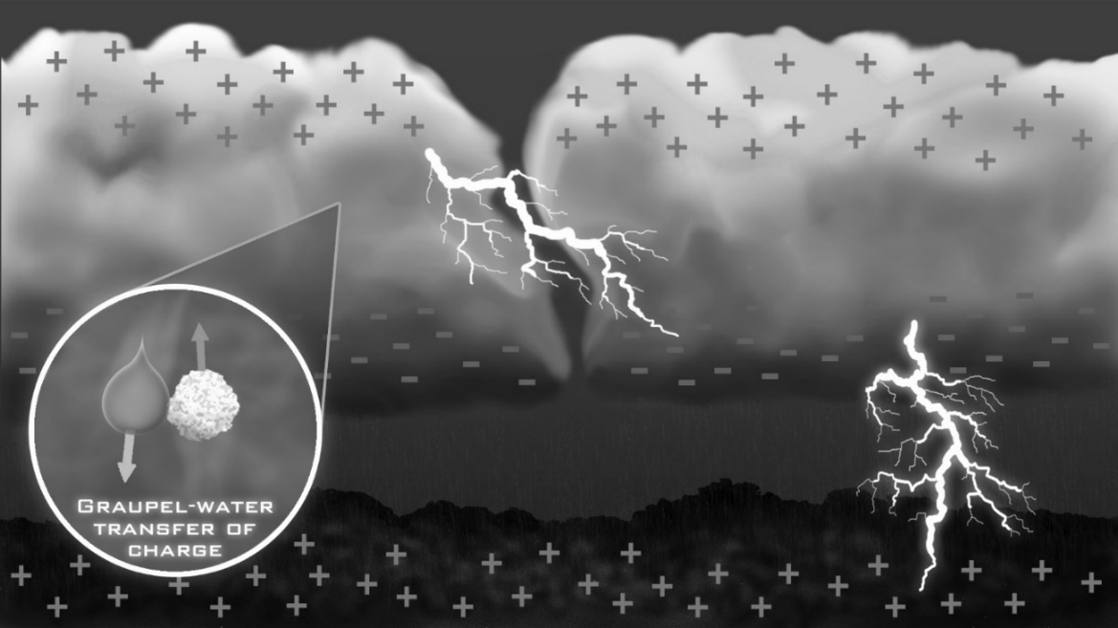
Part 2: The diagrams below show four pairs of identical conducting spheres with identical separations far from other pairs. The value of an initial charge placed on each sphere is indicated.
-8q
8q
C
2q
-6q
D
8q
10q
B
0
4q
A

- Note that the left sphere of pair A initially has a charge of zero. Does that mean that it doesn’t have any electrical charge? Explain.

__________________________________________________________________________________

__________________________________________________________________________________

- Which of the pairs of spheres has a repulsive force between them? Explain.

__________________________________________________________________________________

__________________________________________________________________________________

- Each pair of spheres is briefly brought into contact allowing them to transfer charge. They are then moved back to their initial separation. Specify the new charge values after contact in the second row of icons below.

A’

B’

D’

C’

- Which of the pairs of primed spheres now has an attractive force between them? Explain.

__________________________________________________________________________________

__________________________________________________________________________________

- Rank each pair of spheres in increasing order of the magnitude of the amount of charge transferred when their individual spheres touched.

Ranking: ________ ________ ________ ________

- Note that the force between the primed spheres is given by Coulomb’s Law. Rank each pair of spheres in increasing order of the magnitude of the force between them.

Ranking: ________ ________ ________ ________

