Differentiation – Worksheet to follow the viewing of the demonstration movie available at:
http://astro.unl.edu/video/demonstrationvideos
Row | Quantity #1 | Comparison | Quantity #2
A | the density of Al | > = < | the density of Pb
B | the mass of 1 kg of Al | > = < | the mass of 1 kg of Pb
C | the volume of 1 kg of Al | > = < | the volume of 1 kg of Pb
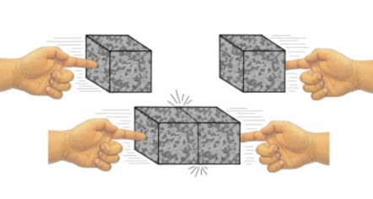

Two cubes of Pb
are merged
(used in rows D and E)

D | the density of the original left cube | > = < | the density of the new object (merged cubes)
E | the mass of the original left cube | > = < | the mass of the merged cubes
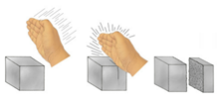
A cube of Al is sliced into
two pieces (one 2/3 of the volume,
one 1/3 of the volume)
(used in rows F and G)

F | the volume of the left (split) piece of Al | > = < | the volume of the right (split) piece of Al
G | the density of the left (split) piece of Al | > = < | the density of the right (split) piece of Al
1. The following quantities are related to cubes of Aluminum (ρ_{Al} =2.7 g/cm³) and Lead (ρ_{Pb}=11.3 g/cm³). (Note ρ_{Water}=1.0 g/cm³). Indicate how the two quantities compare by circling the appropriate comparison operator.

2. A hypothetical planet forms that is composed of 1/3 Al, 1/3 Pb, and 1/3 Fe (ρ_{Fe}=7.8 g/cm³) by volume. After formation the object’s temperature rises due to heat from radioactive decays and it becomes completely molten. It then differentiates and later cools and solidifies. Sketch a cut-away diagram of the object labeling the composition of any distinct regions.

3. A chef creates a new dressing that is half oil (ρ_{oil} =0.9 g/cm³) and half aged balsamic vinegar (ρ_{Vin} =1.2 g/cm³) by volume. The mixture is well-shaken and three black cherry tomatoes (ρ_{CTom} =1.1 g/cm³) are added for decoration. Sketch the final appearance of the dressing container after considerable time has passed indicating the composition of any distinct regions.

