Thermal Transport: Convection – Worksheet to follow the viewing of the demonstration movie at
http://astro.unl.edu/video/demonstrationvideos

- The diagram below represents a slab of the material that makes up the visible surface of the sun.
- Circle the quantity that best describes the value of the variable at the position labeled A.
Temperature: hotter average colder
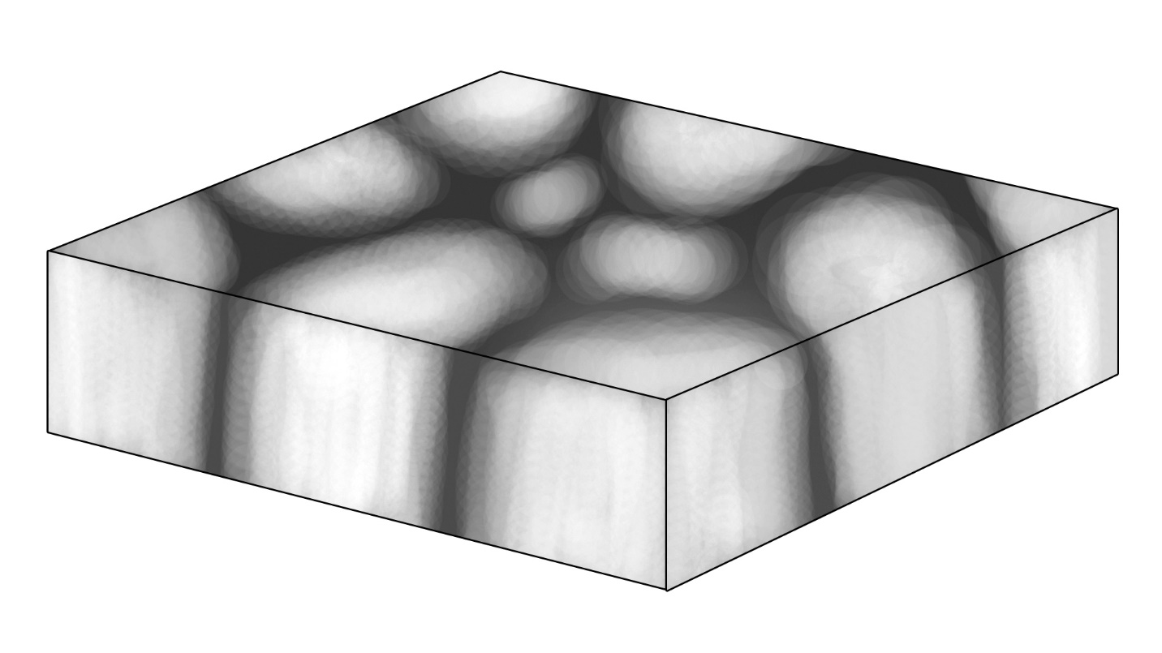
Motion: rising still sinking
Density: high average low

A
B

- Circle the quantity that best describes the value of the variable at the position labeled B.
Temperature: hotter average colder
Motion: rising still sinking
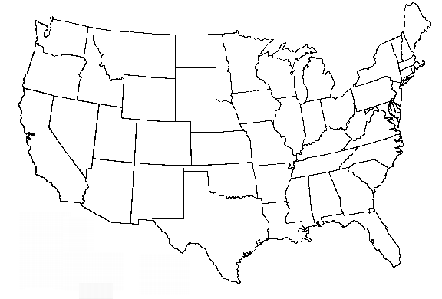
Density: high average low

2.) Convection cells on the sun are about 1000 km in diameter. Draw the convective cell at position A on top of the map of the United States as a circle using your best estimation of the proper scale. (Hint: the distance from New York City to Los Angeles is ~4,000 km)

