Angular Momentum Worksheet
(to follow the video at
https://www.youtube.com/watch?v=1Bdyrv3cc0M)

Directions: Completely answer the following questions (using appropriate physics vocabulary and concepts).

1. The graphic below shows the top view of a merry-go-round with seated children (labeled with letters) aboard. Note that the merry-go-round has a well lubricated axle and it will rotate for a quite once started.
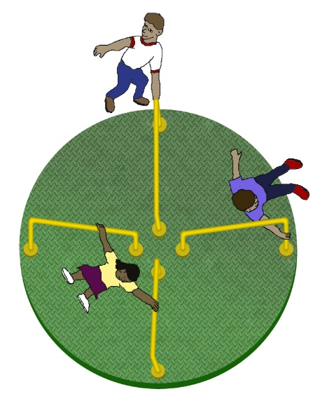
The merry-go-round is given a good push by a supervising parent. Immediately afterwards, identify with a checkmark whether each of the following quantities is larger for child A, for child B, or if they are the same. Please follow each determination with a short explanation of why you reached this conclusion.
A
B
 | Child A | Child B | the Same
- Distance from the axis of rotation (in m)
Explanation:

- period of revolution (in s)
Explanation:

- angular velocity (in rev/sec)
Explanation:

- velocity (in m/s)
Explanation:

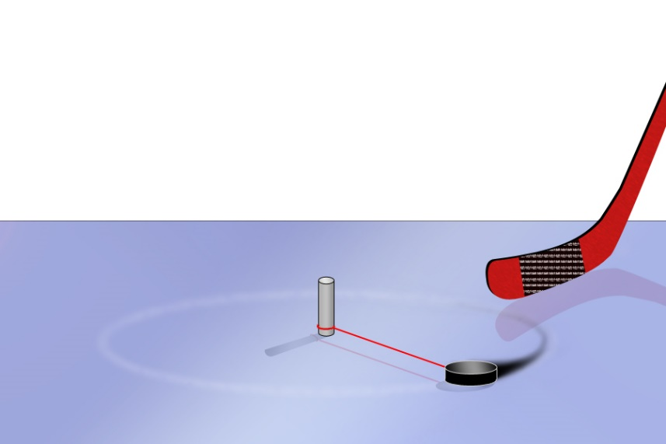

2. A lazy hockey player tires of whacking his puck and having to skate a long way to give it another slap (since there is very little friction on the ice). So he uses a string tightly tied to a spike he has pounded into the ice to restrain his puck. Describe what now happens when he takes another slapshot on the ice.

____________________________________________

____________________________________________

____________________________________________

__________________________________________________________________________________________

__________________________________________________________________________________________

__________________________________________________________________________________________

__________________________________________________________________________________________

Application to Binary Pulsars
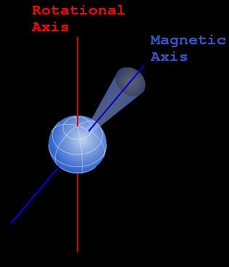
Pulsar Review: Neutron stars are the end states of massive stars that have gone supernova and leave behind a collapsing core. The collapse is eventually stopped by neutron pressure when the neutron star is about 10 km in radius. Due to the conservation of angular momentum, they rotate rapidly. Neutron stars have strong magnetic fields (because neutrons have a magnetic field and they add up) and the magnetic axis of the neutron star doesn’t typically align with the rotational axis. Charged particles are accelerated by the magnetic field causing beams of radiation to be emitted around the magnetic poles. If a beam is pointed in our direction, we see a periodic flash, and the neutron star is termed a pulsar. A typical pulsar has a rotational period of 1 second (sending a flash our way that often).

3. Interesting things occur when pulsars form in binary star systems. The image below illustrates a pulsar and a lower mass companion that has evolved to form a red giant. Matter now easily escapes from the surface of the red giant and is pulled toward the pulsar. A typical particle is labeled at position A and later at position B immediately before impacting the pulsar.

- Accretion Disks – Describe how the labeled particle travels from the Red Giant to the Pulsar -- what will be the speed and path of the particle as it moves from position A to position B? Is angular momentum conserved for the particle along the journey?

__________________________________________________________________________________________

__________________________________________________________________________________________

__________________________________________________________________________________________
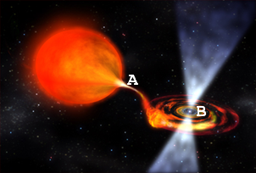
Image Citation: NASA/Dana Berry
______________________________________________________

- Millisecond Pulsars – What do you think the effect will be on the pulsar when the particle (and many similar particles) impact the pulsar? Will this affect the period of rotation (and thus the rate at which we receive flashes) of the pulsar? Note that angular momentum is NOT conserved for the pulsar.
_____________________________________________________

_____________________________________________________

______________________________________________________

__________________________________________________________________________________________

__________________________________________________________________________________________

__________________________________________________________________________________________

