Temperature 3: Absolute Zero Worksheet
(to follow the video at https://www.youtube.com/watch?v=tH7xbdwBWbM)

In this worksheet we will take another look at the determination of absolute zero, discuss why our result in the video wasn’t particularly close to the known value, and try to do better.
The temperature 3 video makes use of a constant volume bulb with a pressure readout – using pressure as a transducer to tell us about temperature. In this worksheet we will add a thermocouple which uses voltage as a transducer. It consists of two wires made of different metals that are connected to form a junction. Both metals have different electrical properties that are a function of temperature. If the ends of the thermocouple are hooked up to a sensitive voltmeter, the junction can be used as a temperature probe. The voltage is read off and used to infer temperature.
Here we have wrapped the thermocouple around the constant volume bulb (using a pipe cleaner to hold it) and connected the other ends of the thermocouple to a calibrated temperature readout on a computer. So we will be able to check whether our reference temperatures are really at the values we assumed in the video.
When we insert the constant volume bulb into a beaker of ice water that we assumed in the video was 0° C. Note that we obtain a higher temperature using the thermocouple (shown on the next page).
- Why do you think that is? Explain your thinking?
__________________________________________________________________________________________
_________________________________________________________________________________________
Temperature Reservoir | T (° C) | P (kPa)
Near Boiling Water | 98 | 120
Room Temperature | 25 | 95
Near Freezing Water | 2 | 88
Near Liquid Nitrogen | -190 | 37

- This table provides the thermocouple temperatures for room temperature and the 3 reference temperatures used in the video. Repeat the determination of absolute zero graphing the 4 temperatures above on the graph paper on the following page. Record your new value: _________________________
The fundamental principle at work in the constant volume bulb is the Ideal Gas Law. There are shortcomings in our procedure (in addition to using an inexpensive pressure gauge):
-- minor problem at all temperatures -- there is air in the bulb, so there are really two different ideal gases present (80% N and 20% O)
-- major problem at cold temperatures -- when we cool nitrogen down near the temperature where it is liquid (-196° C), the oxygen becomes liquid at a higher temperature (-183 °C). Repeat the data analysis omitting the liquid nitrogen point.
Record your new value: _________________________
-- we are also making an extrapolation (estimating a point outside the range of our data points) -- scientists also make interpolations (estimating a value within the range of our data).
- Which is typically preferable (making an interpolation or an extrapolation). Explain why?
__________________________________________________________________________________________
__________________________________________________________________________________________
(Hint: what is the pressure at a temperature of -400 °C?)
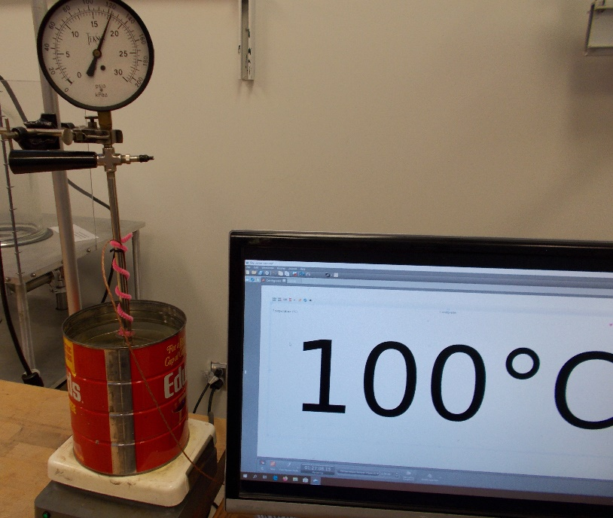
-400
Pressure (kPa)
140
120
80
60
40
20
20
100
0
200
100
-300
-200
-100
-100
Temperature (°C)
Strain × 10⁻³
Determining Absolute Zero

