Astronomy Demonstration Video – Optics 1: Reflection – Worksheet
to follow viewing of the astronomy demonstration video https://www.youtube.com/watch?v=bgTjPs9lmx4

- The Law of Reflection is written as a mathematical formula.
- Write out this equation using only words. __________________________________________
___________________________________________________________________________________
- An air-mirror interface is shown with a ray of light incident upon it. Draw in the reflected ray and label θ_{i} and θ_{r.}
Mirror

- If θ_{i} increases, then θ_{r}_________________.

- When I look into a mirror, θ_{i} is about _____________________ and θ_{r} is about ___________________.

- Two perpendicular mirrors are shown with a ray of light from a red laser incident. Note that the twice reflected ray is drawn for you (and the normals at both locations of reflection are drawn as well).
- Indicate θ_{i1} and θ_{r1} in the diagram (the law of reflection for the first mirror).
Mirror #1
Mirror #2
- Indicate θ_{i2} and θ_{r2} in the diagram (the law of reflection for the second mirror).
- In the space below, write an equation relating θ_{r1} and θ_{i2.} (Hint: Use the fact that the sum of angles in a triangle is 180°)
_________________________________________
- Indicate the sum of all of the angles between the incident ray and the outgoing doubly reflected ray in the equation below:
θ_{i1} + θ_{r1} + θ_{i2} + θ_{r2} = _________

- What does the equation for part d) tell you about the direction of the final outgoing ray?

_____________________________________________________________________________

_____________________________________________________________________________

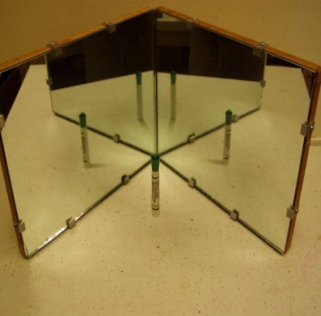
- The picture to the right (which opens the video) shows a pair of mirrors. Note that the angle between the mirrors is slightly less than 90°. When a marker is placed before the mirrors, note that 4 images of the marker are seen by a centrally located observer.

In the diagram below, the apparatus is shown from the top view. The light from the marker that is forming one of the images is shown (ending on a path toward you). Draw in the path of light for the other 3 images (and for those image where the light only reflects off of one mirror – indicate the normal as well).

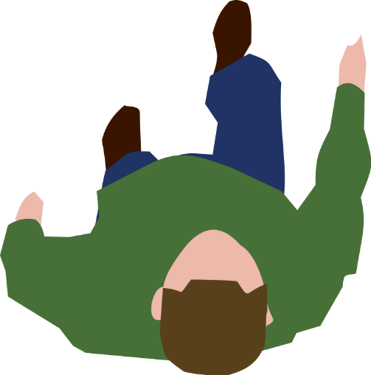
Mirror #1
Mirror #2

