Astronomy Demonstration Worksheet on Planetary Heat
to follow the video at https://www.youtube.com/watch?v=M8FSxebaR8s

Part 1 - Terrestrial Geology:
- In the Planetary Heat video, we saw that the ratio of the Volume to Surface Area for a sphere is R/3 and that this was a useful measure of the heat of formation retained. Fill in the boxes in the table below related to the three spheres representing the planetary bodies in the video. Note that some boxes have been completed for you.
Earth
R_{Earth}= 6400 km

Mars
R_{Mars}= 3900 km

the Moon
R_{Moon}= 1700 km

Earth | Mars | the Moon
Geologic Activity today is …
 | Not readily apparent. An active volcanic eruption has never been observed on Mars, but there was geologic activity not that long ago.
as evidenced in …
 | There is very little cratering on volcanic flows, suggesting that the flows are recent. (say 300 million years ago). But it isn’t clear that there will be more!
because its heat of formation …
 |  | was small since the Moon is a small object and it was all radiated away long ago.

- What would you expect for present geologic activity for the two other terrestrial bodies listed below? Explain your reasoning.
- Mercury (R_{Mercury} = 2400 km)

- Venus (R_{Venus} = 6000 km)
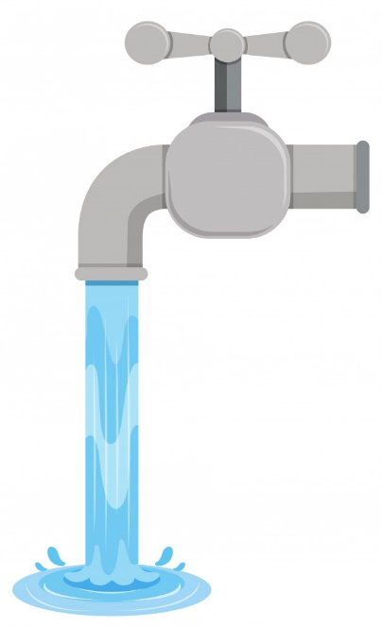
Part 2 - Water Pipes: Answer the following questions related to the diagram of water flow through a “simplified” series of pipes leading to a water faucet.
L
L
R₁
R₂

- What is the formula for volume of a cylinder (of radius R and length L)?

- What is the formula for the surface area of the barrel of a cylinder (of radius R
and length L)? Ignore the end caps of the barrel.

- Write out the expression for the ratio of the Volume/Area for a cylinder. (Check: After
you simplify your expression, you should get a final answer of R/2.)

- One of the many concerns of tap water safety experts is contact with pipes. Long ago pipes were made of lead (and there is still lead solder around at pipe junctions today) which pollutes the water. Today copper (and more recently plastic) pipes are common, but these can be lined with corrosion. It is desirable to minimize the water in contact with pipes.
Using your result in part C), what can you conclude about the water in contact with the cylindrical sections of pipe shown above? Fully explain your reasoning.

__________________________________________________________________________________________

__________________________________________________________________________________________

__________________________________________________________________________________________

__________________________________________________________________________________________

- Make up a descriptive name for the ratio calculated in part C).

- You wake up early in the morning and go to the faucet above to get a drink (knowing that the water has been sitting idle in the incoming pipes all night long). How can you minimize your exposure to water in contact with the surrounding pipe?

