Astronomy Demonstration Video – Eclipses 1 Worksheet
to follow viewing of the astronomy demonstration video at https://www.youtube.com/watch?v=huVCQXYy4jc

- The diagram below (not to scale) provides an overhead view of the Sun-Earth-Moon system. The sun and Earth are shown as well as the shadow cast by Earth.
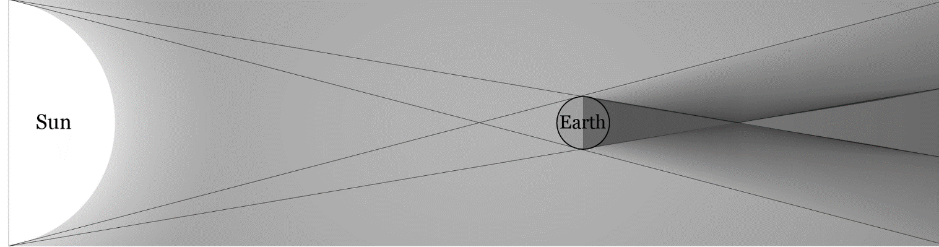
- Add the position of the moon during a total lunar eclipse. Make sure the moon is drawn with the correct relative scale to Earth. Label the three types of shadow cast by Earth.

- Add the position of the moon during a total Solar Eclipse. Draw in the shading on Earth and the moon and the umbra created by the moon.

- Choose the best answer for each of the following multiple-choice questions and the justify your answers making reference to the diagrams you drew above.
- During a lunar eclipse the phase of the moon is …
  - new
  - full
  - any phase is possible
Explain: ___________________________________________________________________________________
__________________________________________________________________________________________
- During a solar eclipse the phase of the moon is …
  - new
  - full
  - any phase is possible
Explain: ___________________________________________________________________________________
__________________________________________________________________________________________3) The moon orbits Earth in an elliptical orbit with an eccentricity of e = 0.055. Because of this the moon varies in angular size. The table on the next page lists the distance and angular size of the moon on a number of random dates.
Date | Earth - Moon Distance | Moon’s Angular Size
Jan. 4th 1912 | 356375 km | 0.558
April 23rd 1930 | 400267 km | 0.501
Mar. 27th 1952 | 376697 km | 0.532
Aug. 10th 1987 | 359861 km | 0.557
Feb. 2nd 1988 | 405948 km | 0.494
Sep. 12th 2018 | 403763 km | 0.497
Feb. 10th 2019 | 397939 km | 0.504
Dec. 25th 2020 | 404837 km | 0.495
July 8th 2080 | 401871 km | 0.499
Feb. 3rd 2125 | 406720 km | 0.493

- Using the table above and assuming the Sun consistently has an angular size of 0.5°, at what range of Earth-Moon distances is an annular eclipse possible? Explain your reasoning.
__________________________________________________________________________________________
__________________________________________________________________________________________
- Is it possible to tell from the above table if an eclipse will occur on any one of these dates? Explain your reasoning.
__________________________________________________________________________________________
__________________________________________________________________________________________
4) The diagram below shows Earth, moon, and their umbras created by the sun (far left).
- How do the umbras of Earth and the moon compare in size?
__________________________________________________________________________________________
- Why are there never lunar annular eclipses? Be sure to include the terms umbra and antumbra in your explanation.
__________________________________________________________________________________________
__________________________________________________________________________________________

