Eclipse Seasons Worksheet
(to follow the video at https://www.youtube.com/watch?v=-kw6pW46saI)
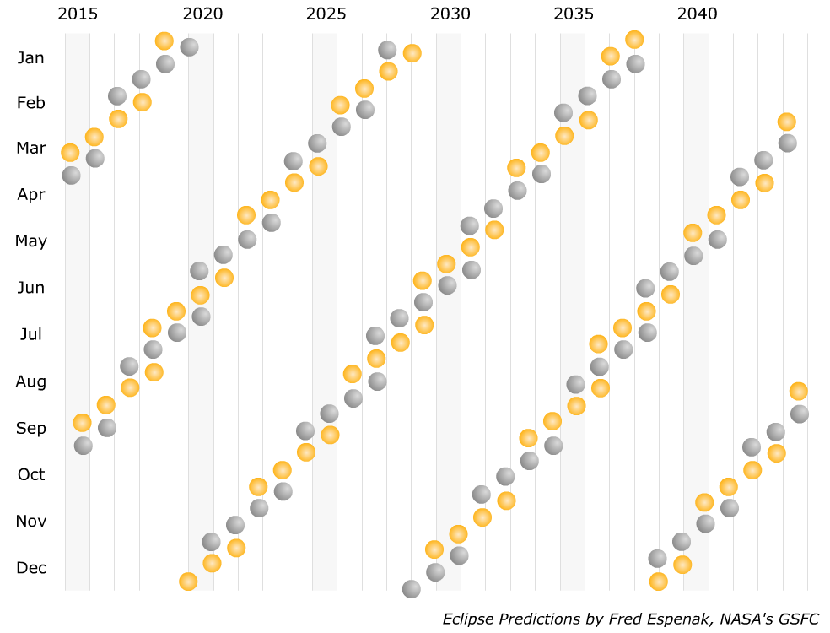
1. Please make the requested annotations to the eclipse prediction diagram below.
a) Create an annotation to the diagram above that clearly illustrates the length of an eclipse season, label its length in time, and explain your thinking below.
__________________________________________________________________________________________
__________________________________________________________________________________________
b) Create an annotation to the diagram above that clearly illustrates the time between eclipse seasons, label its length in time, and explain your thinking below.
__________________________________________________________________________________________
__________________________________________________________________________________________
c) Use the diagram to help you answer the question “How many eclipses are there in a year and what are their types?” Explain your thinking.
__________________________________________________________________________________________
__________________________________________________________________________________________
2) The diagram below illustrates Earth and the moon as seen from the sun. The date shown is March 25 in the year 2038 and at the instant shown the moon is moving directly toward the sun. 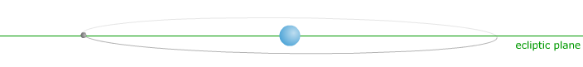
a) Add the label “a” to the eclipse prediction diagram in part 1 on 3/25/2038. Note that the moon at this time is NOT in an eclipse season.
b) Now consider the date July 2, 2038 and add the label “b” to the eclipse prediction diagram in part 1. Note that the moon at this time is in an eclipse season and the line of nodes is pointing directly toward the observer on the sun.
c) Redraw the diagram in part a (Earth, moon, and the lunar orbit as seen from the sun) for the date of July 2, 2038 while a solar eclipse is occurring.

d) The video talks a lot about the 6° orbital inclination of the lunar orbit. Please add an arc and a label conveying this orbital inclination to the diagram you have drawn in the box above.
e) Describe the motion of the moon relative to the observer on the sun on July 2, 2038.
__________________________________________________________________________________________
__________________________________________________________________________________________
f) Imagine that instead of a 6° orbital inclination, the moon’s orbit had an orbital inclination of 15° with all other orbital parameters remaining the same. Redraw the diagram for July 2, 2038 with this 15° inclination.

g) How would the 15° inclination affect the length of an eclipse season and time interval in between eclipse seasons?
__________________________________________________________________________________________
__________________________________________________________________________________________

