Armillary Sphere 2: The Arctics Worksheet
to follow the video at
https://www.youtube.com/watch?v=xd7ZU-aMFoA

Guided Example – It is advantageous to picture the observer’s meridian both above and below the horizon plane when modelling paths of the sun near Earth’s poles. We can accomplish this using a circular protractor that spans all 360°. Note that in this representation, a line connecting the NCP and the SCP represents the rotational axis of Earth.
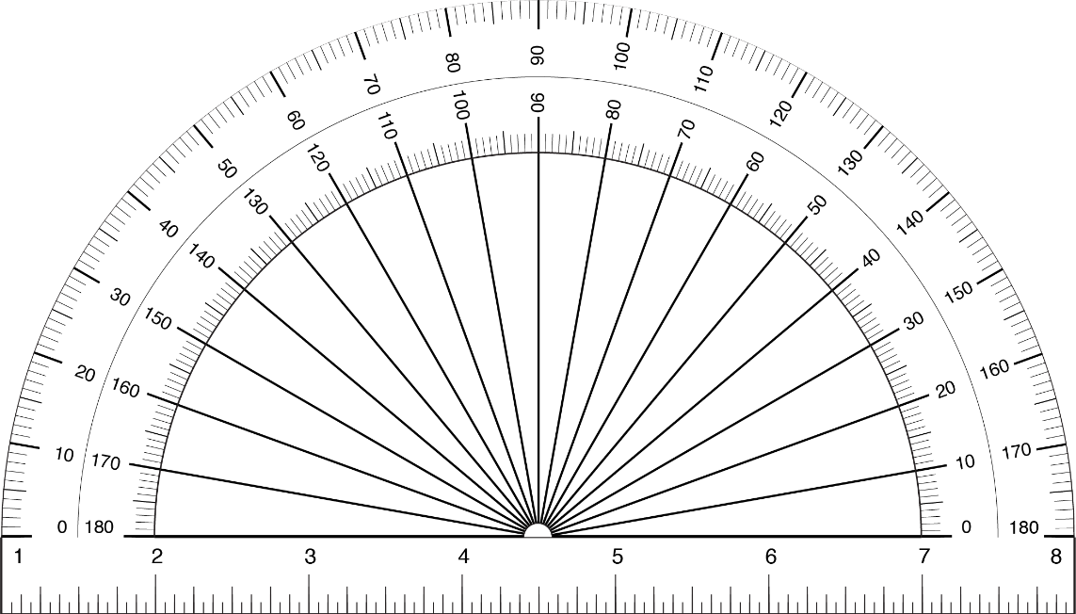
NCP
Z
N
Horizon Plane
Meridian
Meridian
S
Nadir

SS
CE

WS

SCP

The circular protractor above has been configured for latitude near a pole (determining the locations of the NCP, SCP, rotational axis, and CE as well as the 2-D representations of the path of the sun on an equinox and the two solstices. Use the diagram to help you answer the following questions for this value of latitude.

- What is the latitude of the observer? |  | °
- What is the meridional (noontime) altitude of the sun on the equinoxes? |  | °
Remember that the path of the Sun on the summer solstice (SS) has a declination of +23.5° and on the winter solstice (WS) has a declination of -23.5°. The path of the Sun on these days is indicated in the diagram.
- What is the meridional (noontime) altitude of the sun on the summer solstice? |  | °
- What is the meridional (noontime) altitude of the sun on the winter solstice |  | °
- Which day(s) of the year does this observer experience the midnight sun?

____________________________________________________________________________

Student Problem – Consider an observer at a latitude of 85° N. Annotate the diagram below as specified and use it to answer the following questions:
Z
N
Horizon Plane
Meridian
Meridian
S
Nadir
- Label the NCP, SCP on the protractor below for an observer who lives at a latitude of 85° N, draw in the rotational axis connecting the poles.

- Add and label the celestial equator (CE), making sure that it is perpendicular to Earth’s rotational axis. You should add both meridional altitudes for the CE and draw in the line representing it in 2-D.

- How does this observer (living very near the north pole) experience the sun on the vernal equinox?
______________________________________________________________________________
______________________________________________________________________________
- How much does the Sun’s altitude vary, in degrees, over the course of this day (the vernal equinox) for this observer?
______________________________________________________________________________
______________________________________________________________________________

- Add the 2-D paths of the Sun on the summer solstice (SS) and winter solstice (WS) by drawing the two lines that are parallel to the CE to show that the Sun has a declination of +23.5° on the SS and -23.5° on the WS.

- Enter the highest and lowest values for meridional altitude values that the sun has on the SS and WS. Some of these values will be negative reflecting that the sun is below the horizon.

-- Maximum value on the SS |  | °
-- Minimum value on the SS |  | °
-- Maximum value on the WS |  | °
-- Minimum value on the WS |  | °

- Roughly estimate which day(s) of the year does this observer at 85° N experiences the polar night (the sun never rises)?
______________________________________________________________________________
______________________________________________________________________________

